Project Design Phase
Solution Architecture
Date | 27 February 2026
Team ID | LTVIP2026TMIDS78907
Project Name | Optimizing user, group and role management with access control and workflows
Maximum Marks | 4 Marks

Solution Architecture:
The proposed solution architecture defines the high-level structural framework of a system designed to optimize user, group, and role management with integrated access control and automated workflows. The architecture follows a modular, layered, and scalable web-based design to ensure security, maintainability, flexibility, and high performance. It integrates User Lifecycle Management, Role-Based Access Control (RBAC), and approval workflow automation into a unified access governance platform.
Architectural Overview
The system is designed using a three-tier architecture, consisting of:
- Presentation Layer
- Application Layer
- Data Layer
This separation of concerns enhances flexibility, simplifies maintenance, and allows independent scaling of each layer.
1. Presentation Layer
The Presentation Layer provides a responsive web-based user interface accessible to administrators, managers, and end users. It facilitates user interactions including:
- User authentication (login/logout)
- Access request submission
- Role and group assignments
- Dashboard visualization and reporting
- Approval and rejection of workflow requests
The frontend communicates securely with backend services via RESTful APIs over encrypted HTTPS connections. This ensures secure data transmission and seamless integration with backend components.

2. Application Layer
The Application Layer contains the core business logic and functional components of the system. It is responsible for:
- Authentication and authorization
- Role and group management
- Workflow orchestration
- Access control enforcement
- Audit logging and monitoring
- Notification handling
Core Components:
• RBAC Engine
Implements Role-Based Access Control (RBAC) by evaluating user roles and associated permissions before granting access to protected resources. This ensures strict enforcement of least privilege principles.
• Workflow Engine
Automates routing of access requests to designated approvers based on predefined rules. It maintains approval history, tracks request status, and enforces multi-level approval processes where required.
• Security Services
Implements:
- Token-based authentication (e.g., JWT)
- Session validation
- Password encryption and hashing
- Authorization checks at API and resource levels

3. Data Layer
The Data Layer manages persistent storage of all system data, including:
- User profiles
- Roles and permissions
- Groups and role mappings
- Workflow transactions
- Approval records
- Audit logs
Relational database management systems (RDBMS) are used with proper indexing and relational mapping to ensure:
- High query performance
- Data consistency and integrity
- Referential constraints
Backup, recovery, and disaster recovery mechanisms are incorporated to ensure data reliability and business continuity.
Key Architectural Modules
The system consists of the following modular components:
- User Management Module
- Role and Group Management Module
- Access Control Engine
- Workflow Engine
- Audit and Monitoring Module
- Notification Service
Each module interacts through well-defined APIs, enabling modular development, easier testing, and future extensibility. This modular design also allows integration with external systems such as HR platforms, directory services (e.g., LDAP), and enterprise applications.

Deployment Architecture
The system supports both:
- Cloud-based deployment
- On-premise deployment
It is designed to scale horizontally and vertically to handle increasing numbers of users, roles, and access requests without performance degradation. Containerization and load balancing mechanisms can be implemented to enhance scalability and reliability.
Security is enforced at multiple layers through:
- Encrypted communication (HTTPS/TLS)
- Secure authentication mechanisms
- Strict authorization policies
- Comprehensive audit logging
- Role segregation and least privilege enforcement
Example - Solution Architecture Diagram:
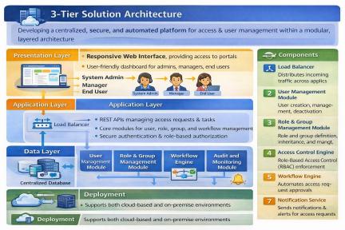
Figure 1: Architecture and data flow of the voice patient diary sample application
Reference: https://aws.amazon.com/blogs/industries/voice-applications-in-clinical-research powered-by-ai-on-aws-part-1-architecture-and-design-considerations/

